### User rights

FT NavVisionhandles control rights by using log-in credentials (username and password), and assigning rights to these credentials. These rights limit access to the system's configuration, therefore ruling out any edits that may harm the system made by unauthorised crewmembers.

Users can be added, edited or removed. Adding, editing and removing users, together with assigning their rights, can only be done by an administrator, i.e. a top-level user.

For every profile made, permissions can be set. The system is delivered with three pre-configured user-profiles, namely:

1. *Administrator*: has all rights;
2. *Guest*: can only use the available viewers;
3. *Operator*: can only alter display mode and/or units.

Login is required upon system start-up. After start-up, users can log off and log in using the dedicated button on the taskbar. By clicking the button, the following window will appear:

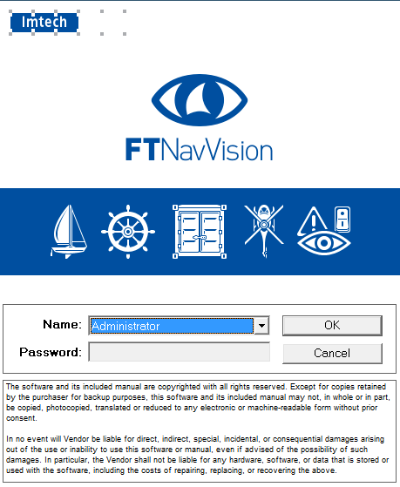

Figure 1‑2: User selection

By clicking the drop-down menu “Name”, you can choose which user you want to start. Provide the password if necessary and click “OK”.